NDG Labs: Capstone Part 1 (Worth 50% of the Capstone Grade)

To complete the lab, you must upload this document with your screenshots inserted.
Submitting any document other than this document will result in a score of 1 for this lab.
For this lab, not correctly performing or missing the Final Screenshot will cost you 99 points.

For this lab, follow the lab direction in this Lab Document. Use the Snipping Tool, or equivalent, to capture the required screenshots.
Follow the instructions for how to properly capture a screenshot provided in the NDG Lab Instructions and Lab 2 Student Template document in the Assignments Folder under NDG Lab Instructions, How-to-Videos, and Module 2 Lab Student Template.

When doing your capstone:
- Review this template to ensure which screenshots you must provide to prove you have completed this portion of the Capstone correctly.

- Screenshots for Part 1 are to be taken after you have completed all parts of this lab, but prior to ending your reservation.

- If a field/box will not allow you to paste your screenshot, it has something to do with the upload/download process in Blackboard. You will need to download this document again and transfer the screenshots you have captured over to the new downloaded template and continue with the lab.

Screenshots required for this lab: Total of 12
Warning:

For this Capstone, not correctly performing or missing the Final Screenshot will cost you 99 points.

If you need to review how to perform the Final Screenshot, view the demonstration video linked below.
https://us-lti.bbcollab.com/recording/f7b9839afae84a17a084385d1b7f99e1

It is highly recommended that you schedule plenty of time to complete Part 1 of the Capstone lab since you only have 3 attempts (Capstone Reservations that you can make this week) See the next page for more details.

You can make an 8-hour reservation and extend it up to 8 times (once the timer reaches 15 minutes) if no other student has reserved the same POD following your current reservation.

Once you have completed your lab, end your reservation so that others can use that POD.

CAPSTONE REQUIREMENT
- All your Capstone screenshots must come from the same reservation.

- You are allowed only three attempts at Capstone Part 1.
  - You can only create three Lab 17: Capstone Lab reservations in NDG during this week of the Capstone (exception to this is below).
    - You will be allowed three more Capstone reservations when Captone 2 is available.
  - You may review other labs/exercises you have performed, to include, making reservations of those labs during this period. Making a reservation for labs 3, 4, 5, etc. is not Lab 17: Captone and does not count as one of your three Lab 17: Capstone reservations.
  - You must perform your Capstone Part 1 lab using only Lab 17:Capstone in NDG.
  - If you have any concerns about your own PC or internet connection, you will want to find a stable setup to perform this lab, especially if you are having to make your third reservation.
    - Your Capstone will not be accepted if you make more than three Lab 17:Capstone reservations a week (minus the exception below)

- Your lab must be uploaded to Blackboard in Landscape Mode to get a grade above a 1.

- If the NDG Lab firewall does not recognize the admin password Pal0Alt0! at the start of your lab.
  - Capture a screenshot of the issue, ensuring the POD number used for your reservation, is visible in your screenshot.
  - Cancel your current reservation, allowing no more than 5 minutes of your reservation time to pass before canceling it.
  - Email your instructor, being sure to attach the screenshot, and explain what POD you were on when it occurred.
  - Finally, make a new reservation on a different POD and restart your Capstone Lab
    - This reservation will not count against one of your three allocations, if you ended the reservation within the 5 minutes above.

- Incorrect screenshots are worth 8 points each.

- Incorrect format for your screenshots is a 2-point deduction per screenshot, up to 11 points.

- Not performing the Final Screenshot correctly will cost you 99 points.

- Not uploading your work as a PDF is a 5-point deduction.

- The Naming Convention of policies, profiles, lists, etc., must follow what is provided in this document.

Lab 17: Capstone

Introduction

Reminder: All your Capstone Part 1 screenshots must come from the same reservation, otherwise, you will receive a score of 1.

This is Part 1 of a comprehensive lab intended to enable you to test your skills and abilities to properly set up a Palo Alto Firewall. You can refer to your student PPTs and earlier lab exercises to aid you in this lab.

In this scenario, you are a firewall administrator and recently received a new Palo Alto Networks VM Series firewall. The firewall’s management IP address is 192.168.1.254. You can log in with the username admin and Pal0Alt0! as the password.
Take special care to use the exact spelling and capitalization for the items you are tasked with configuring.

Objective
You are being asked to meet multiple configuration objectives. These objectives are listed in the lab exercise sections that follow.

Lab Topology

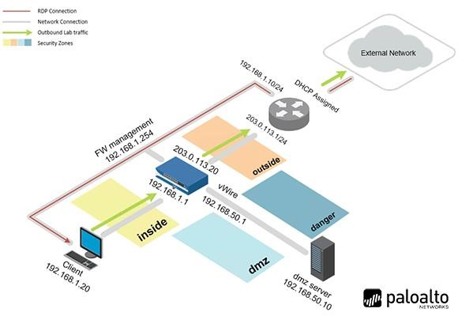

Capstone Part 1

Load Lab Configuration
- In NDG, make and reservice Lab 17: Capstone.
  - For the Capstone, you will not be using the NDG Contents Lab in NDG for the Capstone. These are your Capstone Lab Instructions for Part 1.
  - Ensure you complete Part 1 in a single NDG reservation. (If you make a mistake or need to start over, you may. Just ensure that you retake all screenshots so that they all are from the same NDG reservation.
    - You are limited to three reservations for Capstone Part 1 (minus one exception listed above)
- In the web interface, select Device > Setup > Operations.
- Click Load named configuration snapshot.
- Select edu-210-lab-17a-start.xml and click OK.
- Click Close.
- Commit all changes.

Configure Networking
Complete the following objectives:
- Configure three firewall interfaces using the following values:
  - Ethernet 1/1: 203.0.113.20/24 - Layer 3
  - Ethernet 1/2: 192.168.1.1/24 - Layer 3
  - Ethernet 1/3: 192.168.50.1/24 - Layer 3
- Create a virtual router called VR-1 for all configured firewall interfaces.
- Create a default route for the firewall called Default-Route
- Create an Interface Management Profile called Allow-ping that allows ping
- Assign the Allow-ping Interface Management Profile to ethernet1/2

Configure Security Zones
Complete the following objectives:
- Create a Security Zone called Internet and assign ethernet1/1 to the zone.
- Create a Security Zone called Users and assign ethernet1/2 to the zone.
  - Configure the Users Zone for User-ID
- Create a Security Zone called Extranet and assign ethernet1/3 to the zone.
- Create and assign Tags for each Security Zone using the following names and colors.
  - Extranet – orange
  - Internet – black
  - Users – green

- Create the following Tags using the following names and colors.
  - Allow – Lime
  - Block – Red

Configure NAT Policies

Create Source NAT rules to meet the following requirements:
- Rule Name = Users_to_Internet
  - From Source Zone Users to Destination Zone Internet
  - Use ethernet1/1 on the firewall as the source translation address.
  - Tag = Users
  - Nat rule must include a helpful description

- Rule Name = Extranet_to_Internet
  - From Source Zone Extranet to Destination Zone Internet
  - Use ethernet1/1 on the firewall as the source translation address
  - Tag = Extranet
  - NAT rule must include a helpful Description.

Modify Security Policy Rules

- Modify the interzone-default security policy rule to ensure that traffic is logged at session end.
- Assign the proper Tag to both default security policy rules

Now that you have completed the basic configuration of the firewall, on the following pages, provide the correct screenshots proving you have completed the above tasks correctly.
Your firewall configuration screenshots must show that the changes you have made are active on the firewall (i.e. links must show green, etc.) otherwise they are not completed.

Initial Setup Part 1 – (From the NDG Menu Bar, click on the Client Tab drop down arrow and select Actual Size. Next, click Applications (bottom left) and go to Setting > Display. Take a screenshot of the Display Window showing the Resolution is 1280x768. Ensure you have aligned your PC browser correctly so that your NDG username, the Time Remaining and Trash are aligned. Those with laptop displays less than 1080p, ensure you have adjusted your zoom properly)

Initial Setup Part 2 – Click on the Firewall tab and ENSURE that the firewall has completely loaded, prior to starting the Capstone.

You are not providing the above screenshots
This is to remind you of how your screenshots need to be set up and to ensure the firewall is ready, prior to beginning.

Screenshot 1 - After completing the firewall setup, provide a screenshot of Network > Interfaces > Ethernet confirming you have completed some of the objectives of the Capstone. Ensure all necessary columns and modification changes you had to make are fully visible in the screenshot.
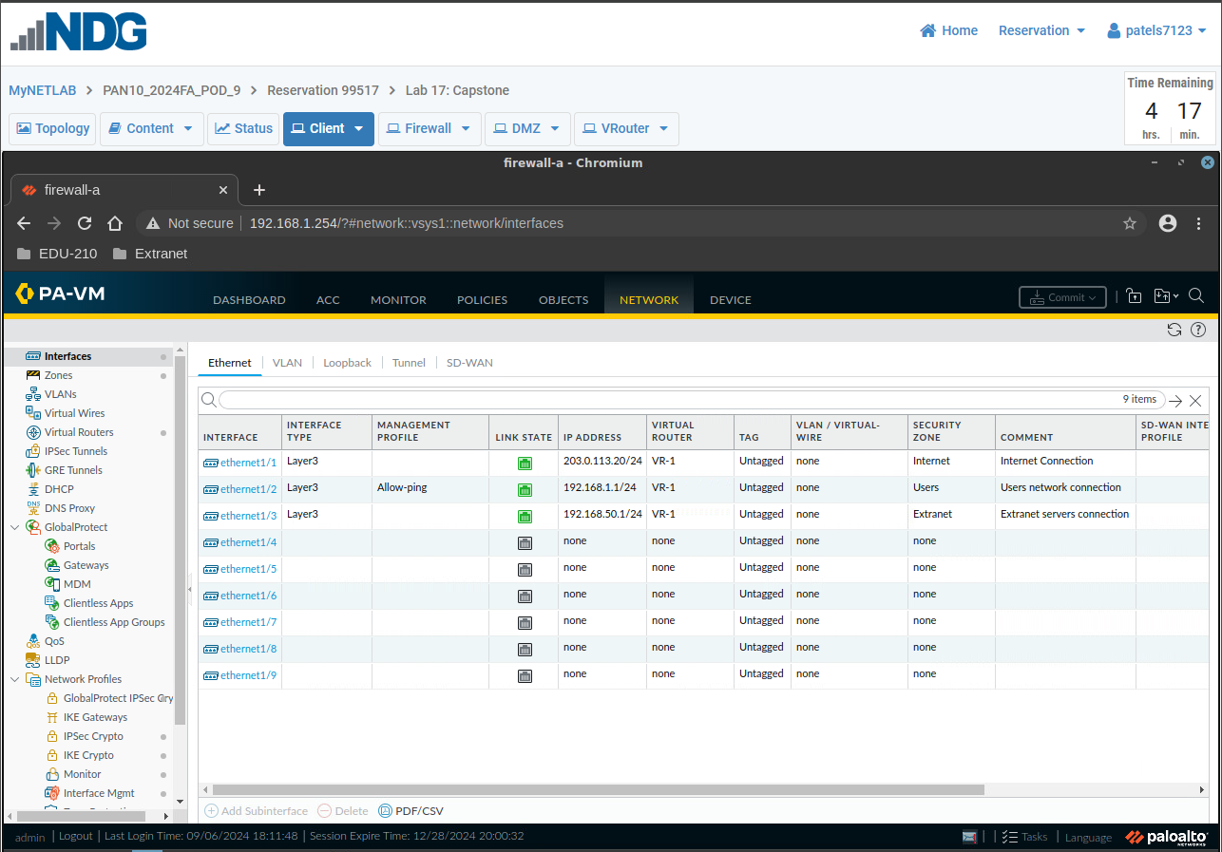

Screenshot 2 - After completing the firewall setup, provide a screenshot of Network > Zones confirming you have completed some of the objectives of the Capstone. Ensure all necessary columns and modification changes you had to make are fully visible in the screenshot.

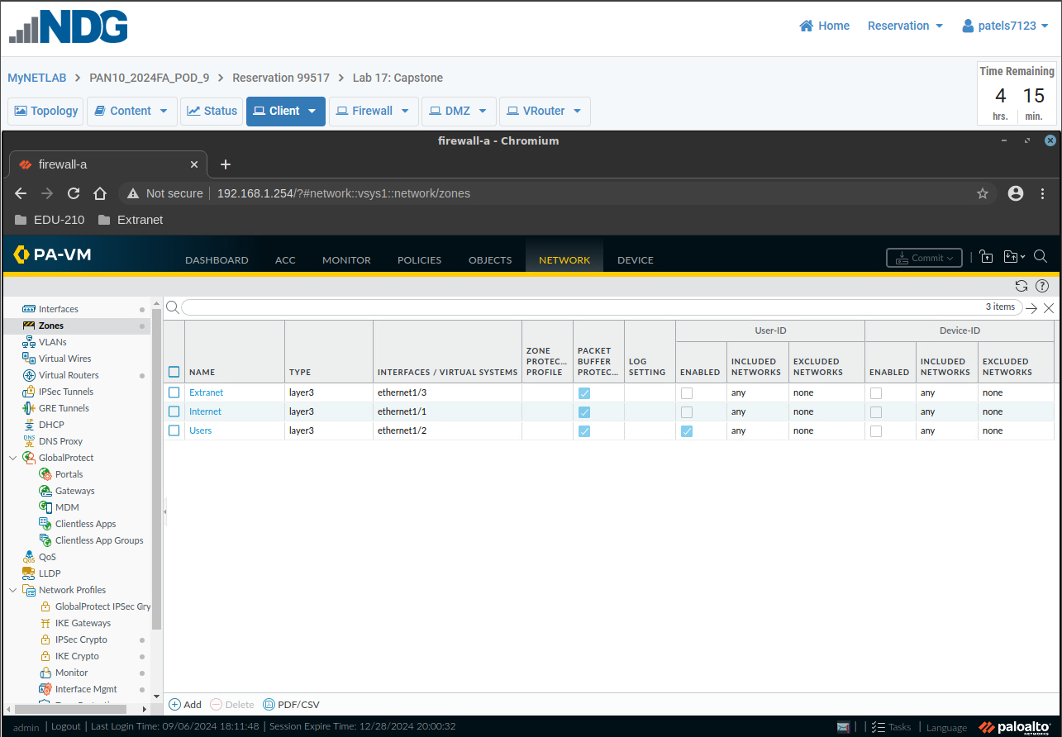

Screenshot 3 - After completing the firewall setup, provide a screenshot of Objects > Tags page confirming you have completed some of the objectives of the Capstone. Ensure all necessary columns and modification changes you had to make are fully visible in the screenshot.
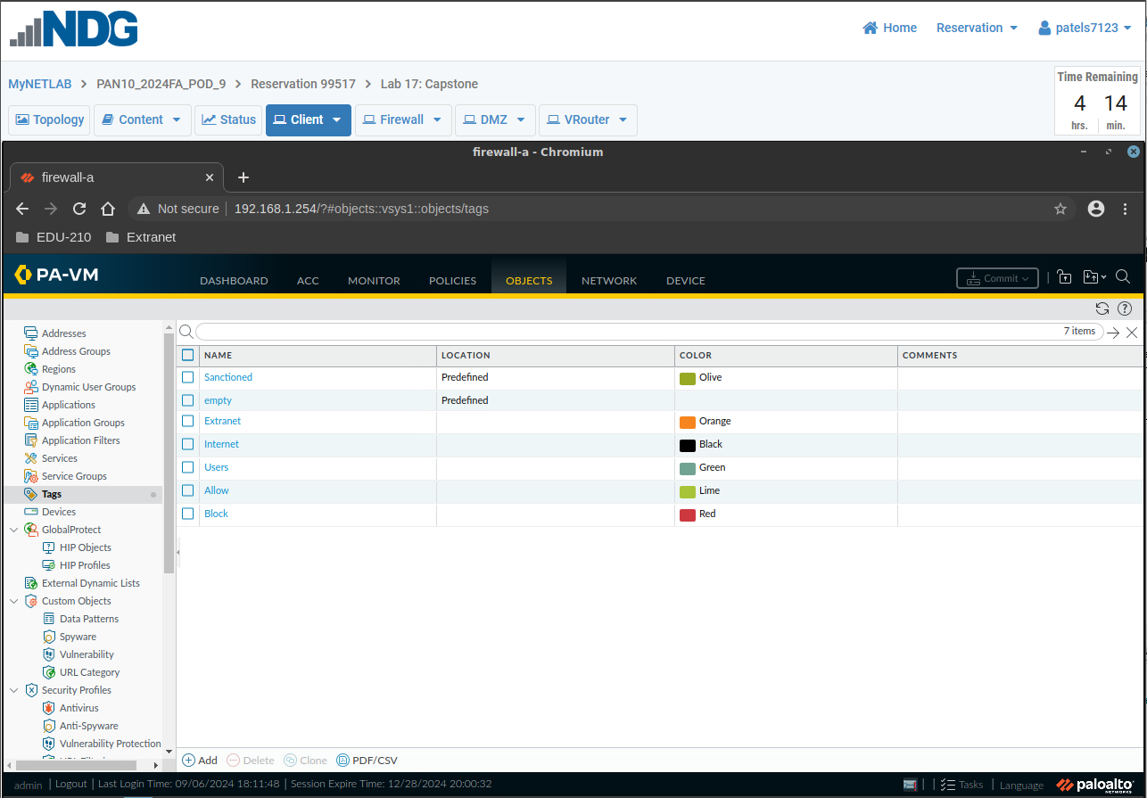

Screenshot 4 - After completing the firewall setup, provide a screenshot of Policies > NAT confirming you have completed some of the objectives of the Capstone to include 17.4a and b. Ensure all necessary columns and modification changes you had to make are fully visible in the screenshot.
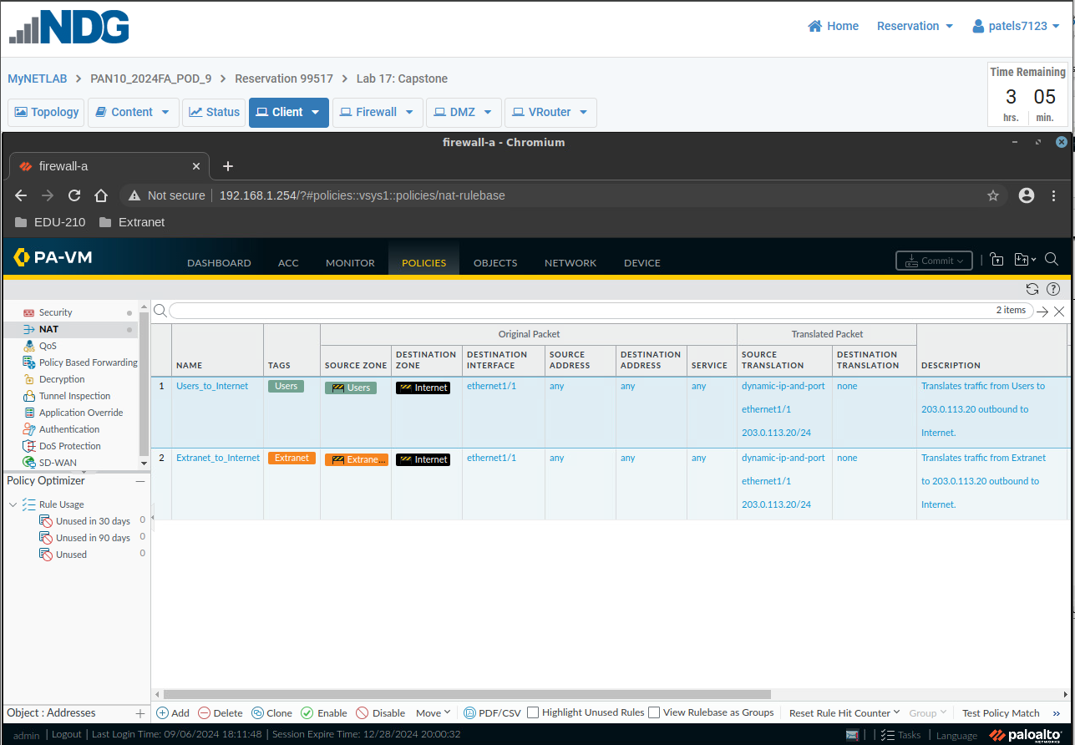

Screenshot 5 - After completing the firewall setup, provide a screenshot confirming you have completed 17.2 Step c of the Capstone.
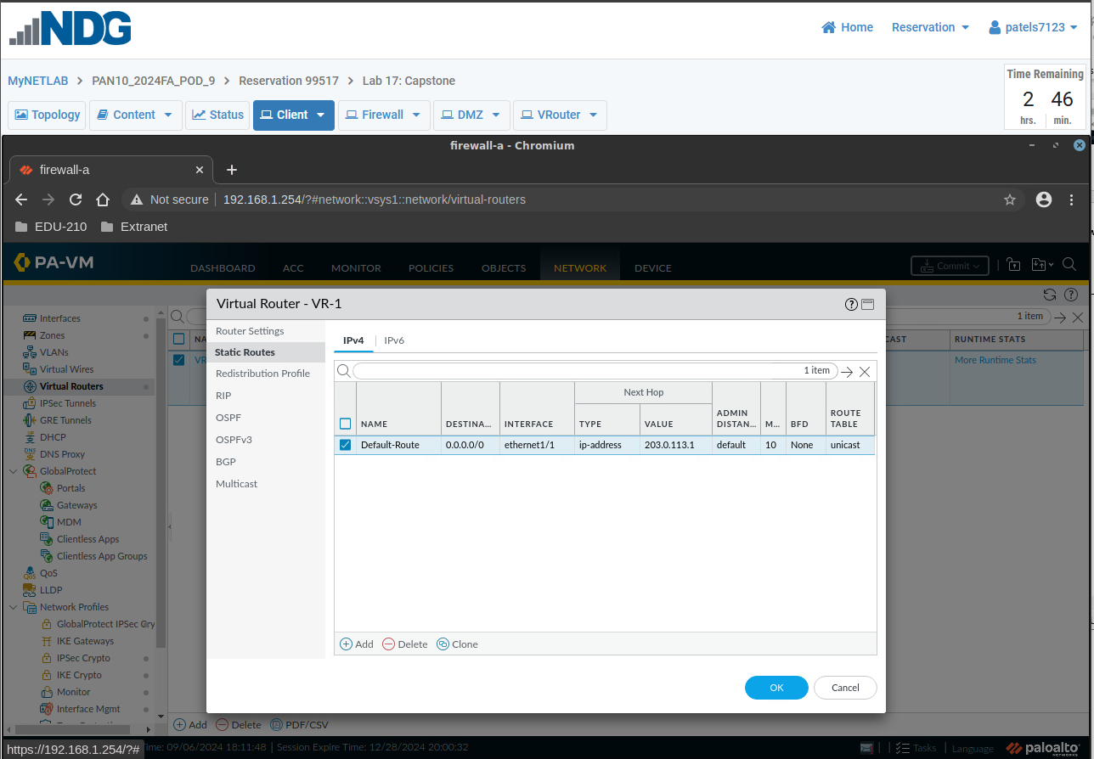

NOTICE TO STUDENTS:
For the terminal and Remmina screenshots:
- You must make the terminal and Remmina windows fullscreen prior to taking your screenshots

- You must clear the terminal/Remmina prior to issuing a new command (you can only have one command and one output visible in each screenshot)

Screenshot 6 - After completing the firewall setup, provide a screenshot showing that your internal host can ping 192.168.1.1 from the client terminal and receive a response. Do not let the ping run for too long.
Ensure the command you entered, and the full ping statistics output, are visible in your screenshot and that it is just one command is in the screenshot (i.e. clear the CLI screen prior to conducting the command above).
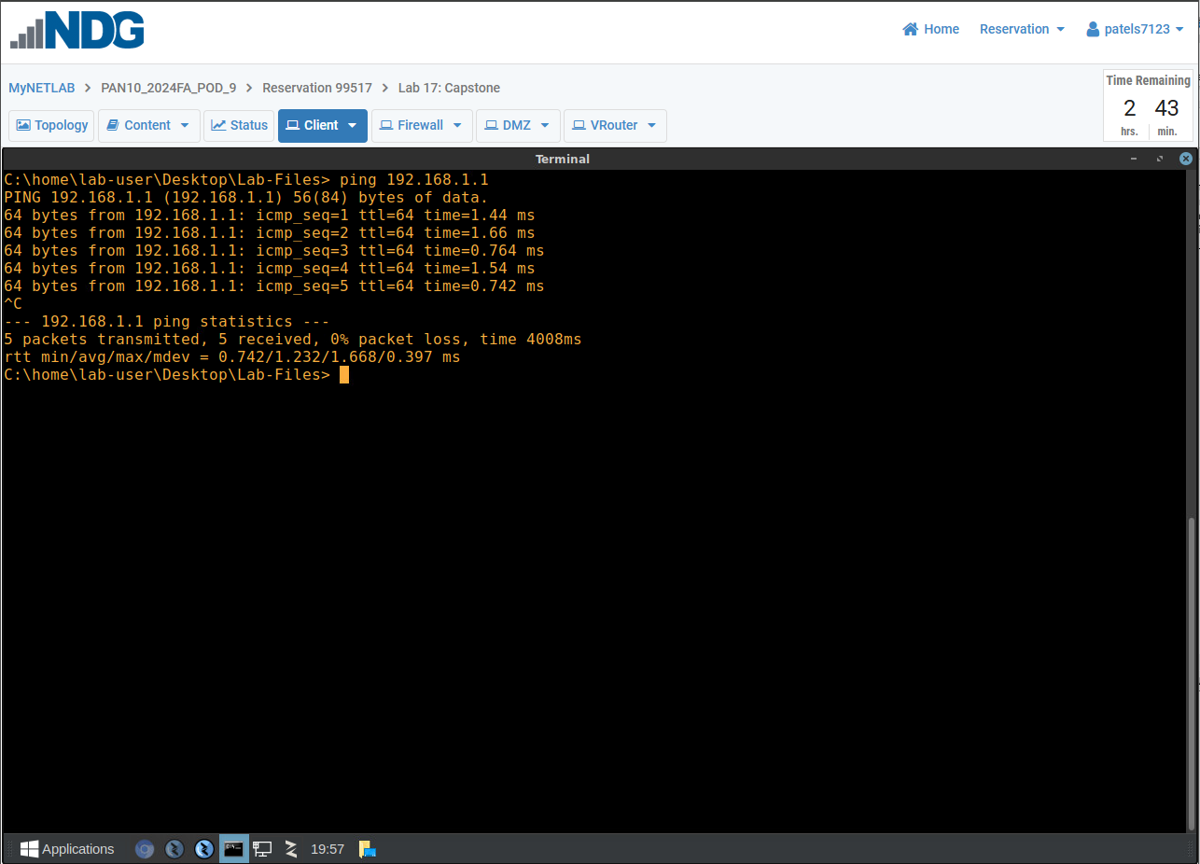

Screenshot 7 - After completing the firewall setup, provide a screenshot showing that from the firewall (via Remmina), you can run the command ping source 203.0.113.20 host 203.0.113.1 and receive a response. Do not let the ping run for too long.
The command you entered, and the full ping statistics output, must be visible in your screenshot. Ensure only one command and its output is in the screenshot (i.e. clear the CLI screen prior to conducting the command above).
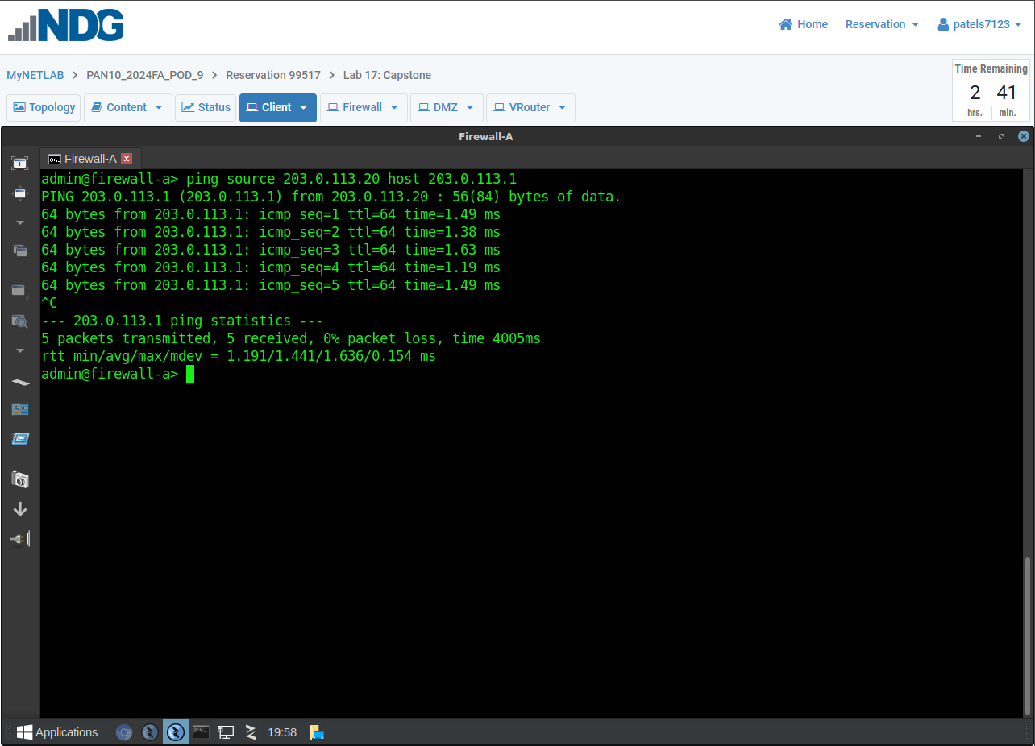

Screenshot 8 - After completing the firewall setup, provide a screenshot showing that from the firewall (via Remmina), you can run the command ping source 203.0.113.20 host 8.8.8.8 and receive a response. Do not let the ping run for too long.
The command you entered, and the full ping statistics output, must be visible in your screenshot. Ensure only one command and its output is in the screenshot (i.e. clear the CLI screen prior to conducting the command above).
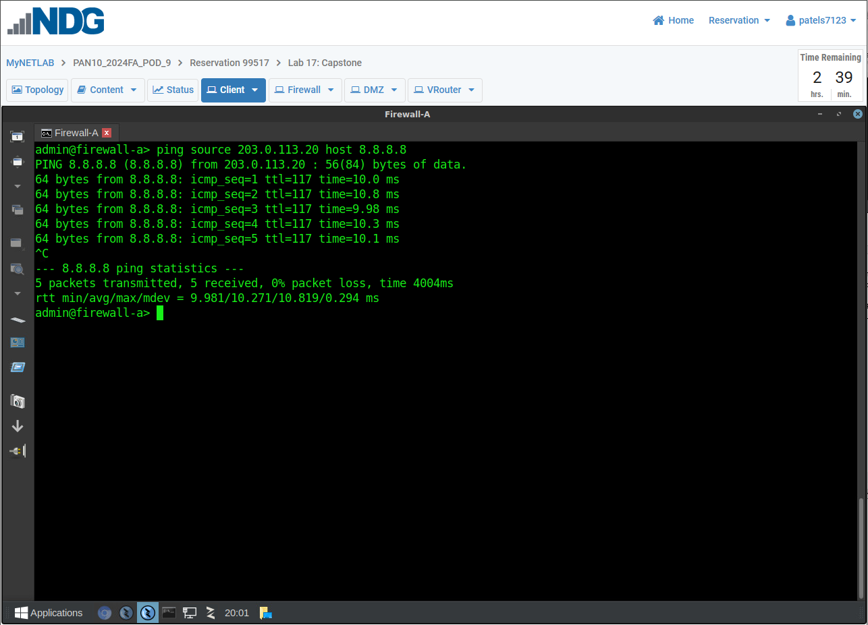

Screenshot 9 - After completing the firewall setup, provide a screenshot showing that from the firewall (via Remmina), you can run the command ping source 192.168.1.1 host 192.168.1.20 and receive a response. Do not let the ping run for too long.
The command you entered, and the full ping statistics output, must be visible in your screenshot. Ensure only one command and its output is in the screenshot (i.e. clear the CLI screen prior to conducting the command above).
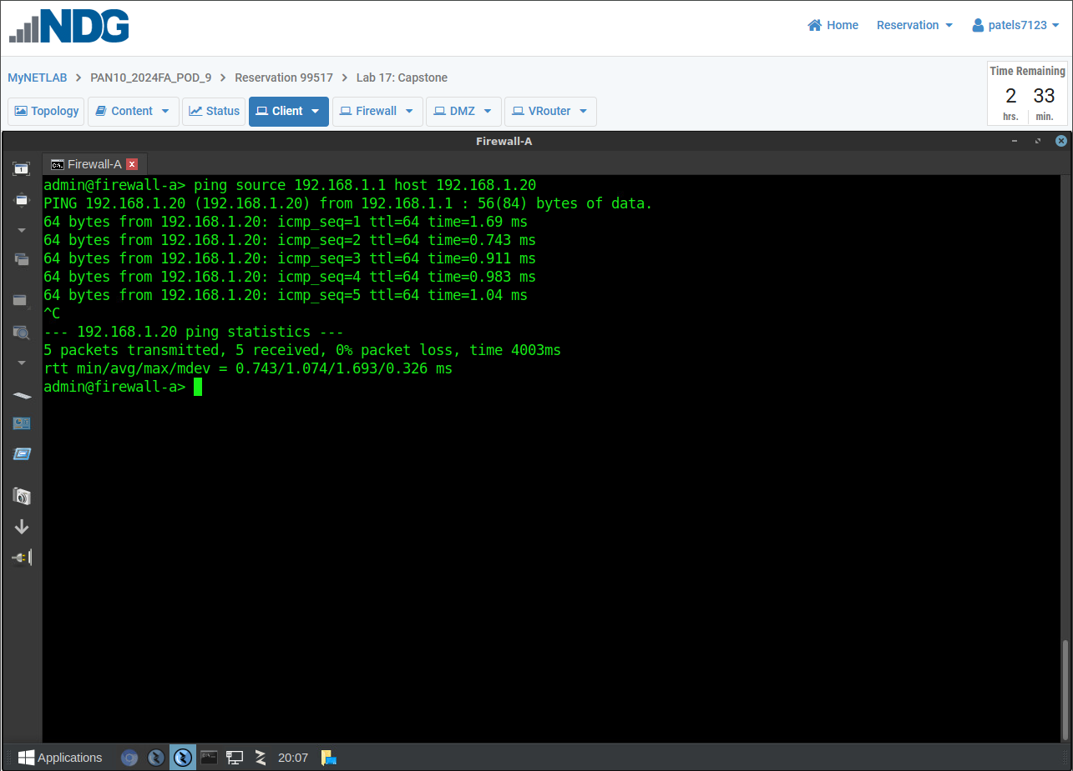

NOTICE TO STUDENTS:
For the POLICIES > Security page screenshot, you must remove the following column prior to taking the screenshots:
Source User

Screenshot 10 - After completing the firewall setup, provide a screenshot showing that you completed the task 17.5 Step a.
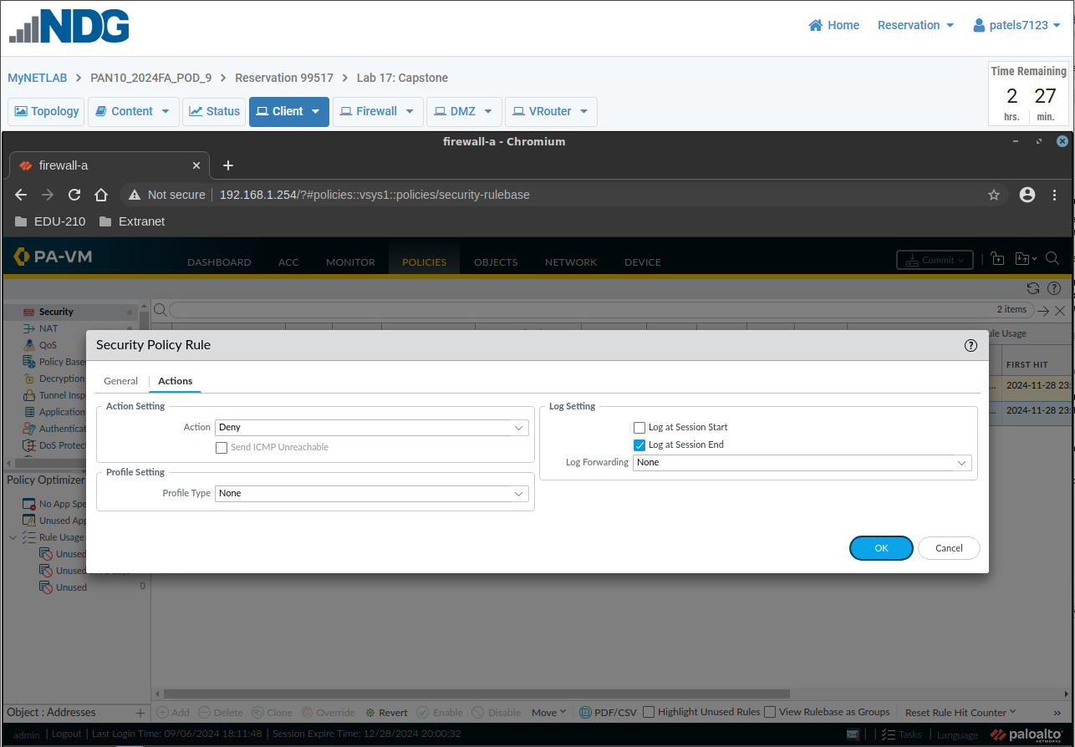

Screenshot 11 - After completing the firewall setup, provide a screenshot ensuring both default security policies on the Policies > Security page are visible, confirming you have completed some of the objectives of the Capstone. Ensure the columns Name over to Options are visible in your screenshot. Ensure all necessary columns, column information and changes you have made are fully visible in the screenshot.
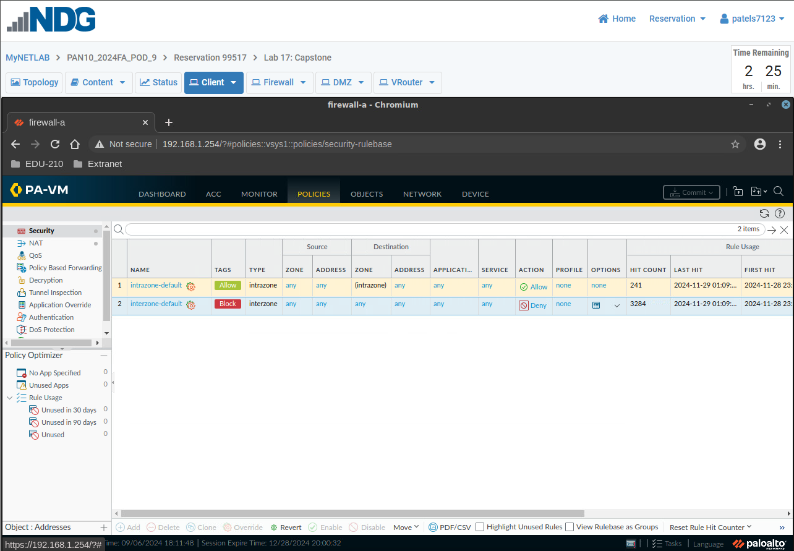

Warning: You are entering a different date for the Final Screenshot for Capstone Part 1

Final Screenshot (Go to Monitor > Logs > System and in the search bar enter the following: (those are single quote marks below)
receive_time geq 2024/11/25 and description contains ‘edu’…………….(Note you are entering a different date!!!!!!)
Take a screenshot of the results.
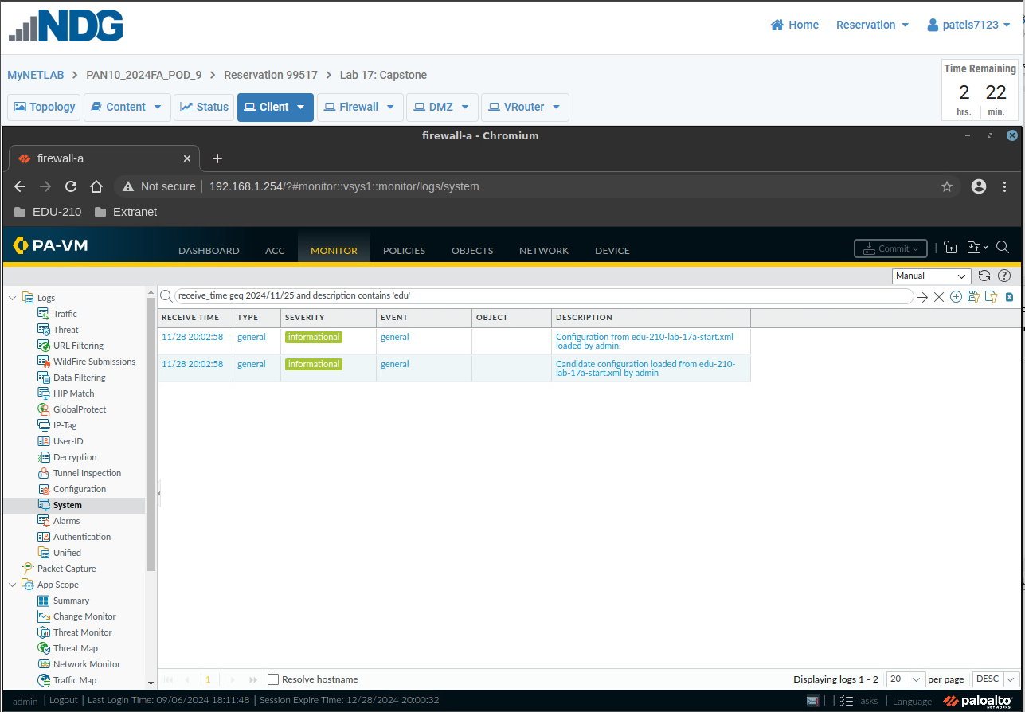

END OF LAB
Remember to save this document as a PDF by choosing Save As and under the name of the file replacing Word Document (*.doc) with PDF (*.pdf) and then clicking on Save.

